Navigate to <https://killercoda.com/login>

After sign in go to

https://killercoda.com/playgrounds/scenario/kubernetes

1. How many pods exist on the system?

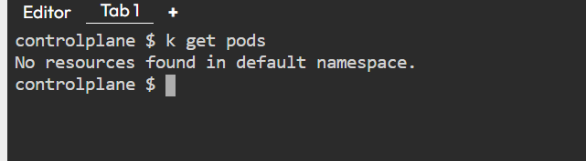

2- How many Nodes exist on the system?

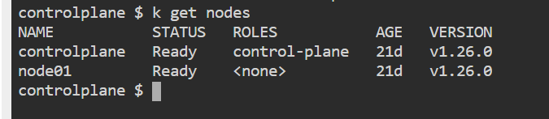

3- Create a new pod with the nginx image.

Image name: nginx

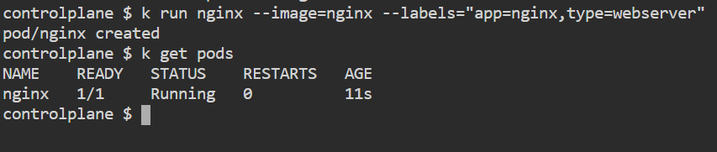

4- Which nodes are these pods placed on?

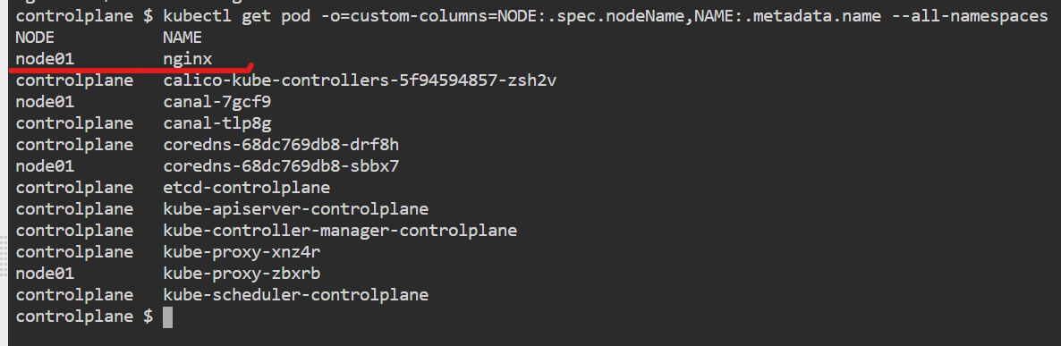

5- Create pod from the below yaml using kubectl apply command

apiVersion: v1

kind: Pod

metadata:

name: webapp

namespace: default

spec:

containers:

- image: nginx

imagePullPolicy: Always

name: nginx

- image: agentx

imagePullPolicy: Always

name: agentx

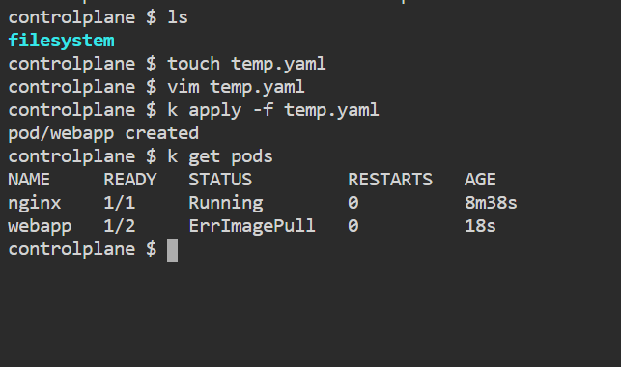

6- How many containers are part of the pod webapp

7- What images are used in the new webapp pod?

8- What is the state of the container agentx in the pod webapp

9- Why do you think the container agentx in pod webapp is in error?

10- Delete the webapp Pod.

11- Create a new pod with the name redis and with the image redis123.

* Name: redis
* Image Name: redis123

12- Now change the image on this pod to redis.

Once done, the pod should be in a running state.

13- Create a pod called my-pod of image nginx:alpine

14- Delete the pod called my-pod